**Assignment on Digital Marketing**

**Name : V.SUDHARSAN**

|  |  |  |
| --- | --- | --- |
| **NM Id** | **:** | **0A9C1CB934BB08ABFFC4C744A84CB8C4** |

* **Create a blog or website using Blogspot and WordPress. Customize the theme design and post new article with 500 words.**

**WORDPRESS**

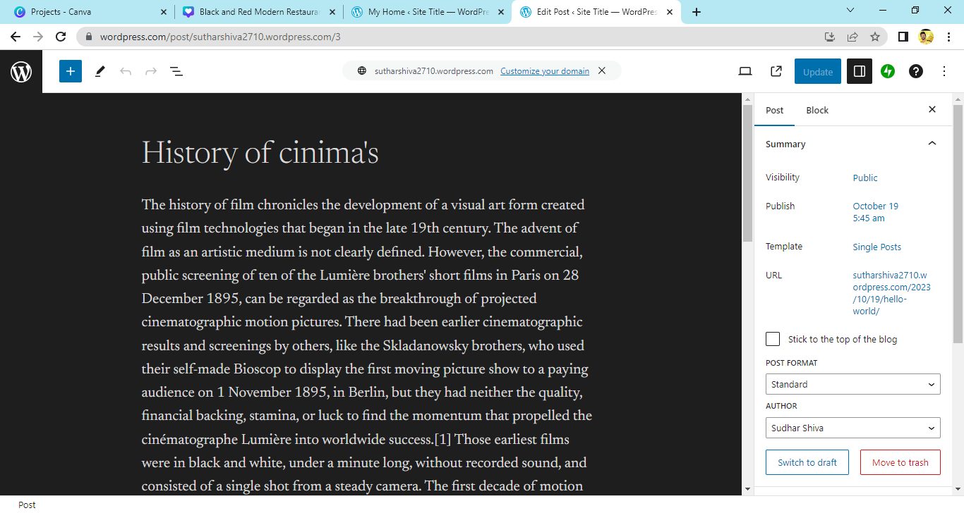

**Hyperlink :<https://sutharshiva2710.wordpress.com>**

* **Create a New Facebook Business Page and post one social media poster for your brand**

**FACEBOOK BUSINESS PAGE**

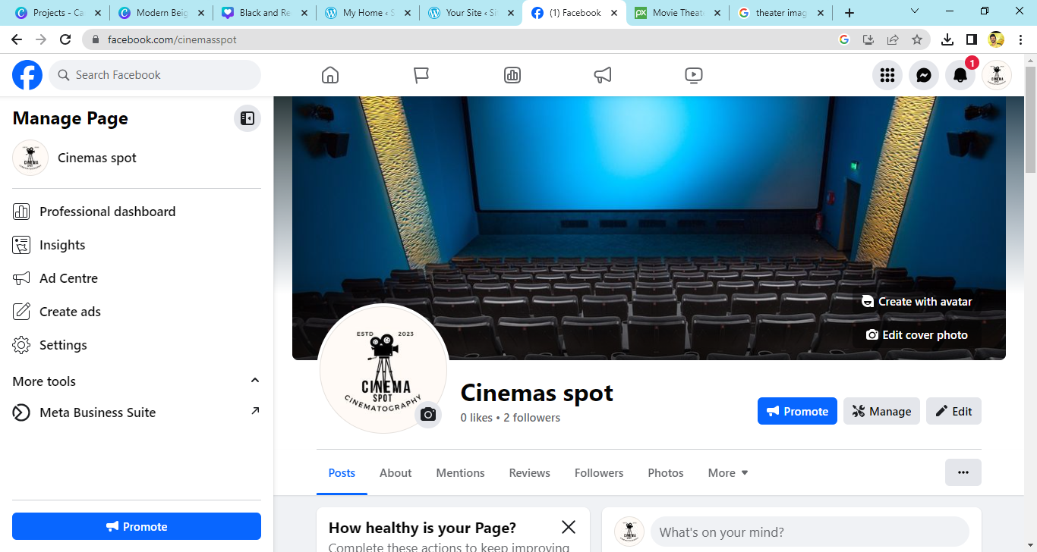

**Hyperlink: <https://www.facebook.com/cinemasspot>**

* **Create and design a social media advertisement poster using canva**

**CANVA ADVERTISEMENT POSTER**

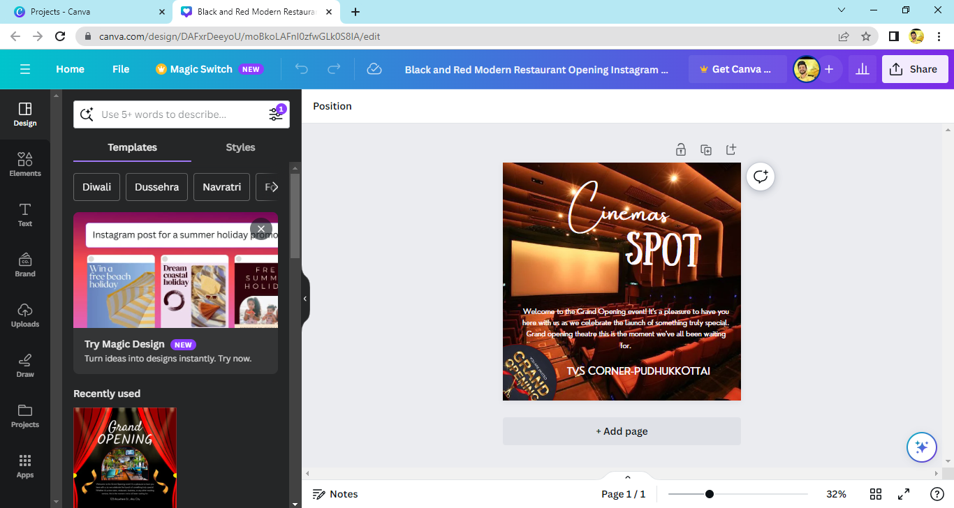

**Hyperlink:<https://www.canva.com/design/DAFxrDeeyoU/iACrfp_PVFzxe-qyh6Axow/view?utm_content=DAFxrDeeyoU&utm_campaign=designshare&utm_medium=link&utm_source=editor>**

* **Create email newsletter design using MailChimp or canva tool**

**CANVA**

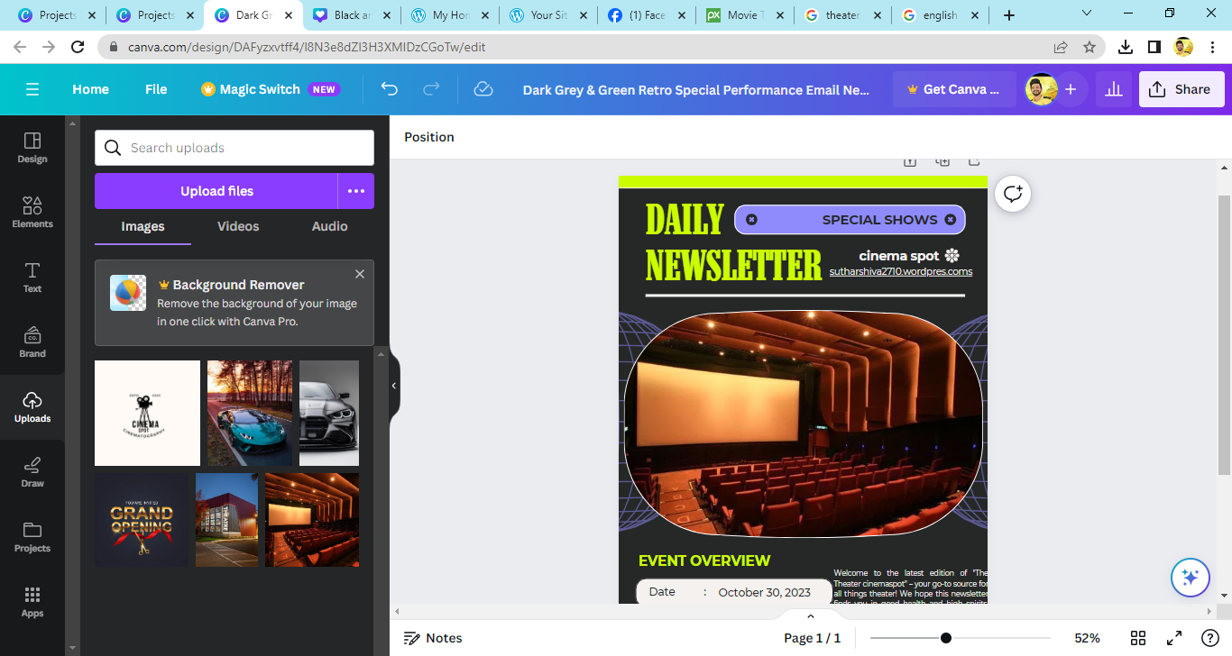

**Hyperlink:<https://www.canva.com/design/DAFyzxvtff4/zPhhl7wq_FDLigGIBVykdw/view?utm_content=DAFyzxvtff4&utm_campaign=designshare&utm_medium=link&utm_source=editor>**